Bizagi Blackbelt tool Installation guide

Briefly the installation is performed in 3 steps:

1. Install the git tools
2. Install BlackBelt
3. Configure a project

## Install Git Tools:

Run the installer: GitExtensions-2.48-SetupComplete.msi (you can download it from here: <http://sourceforge.net/projects/gitextensions/>) and follow these screenshots values:

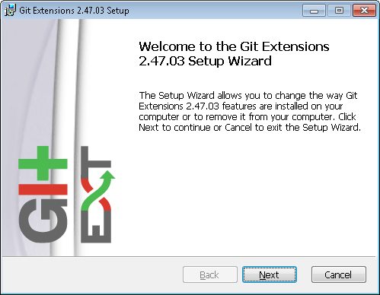

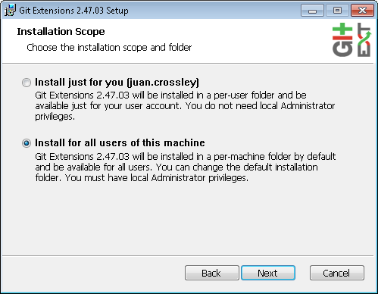

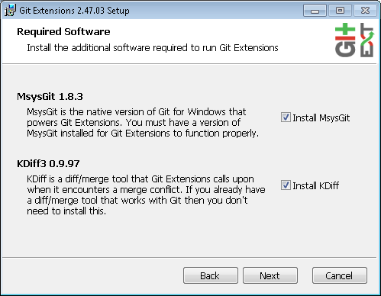

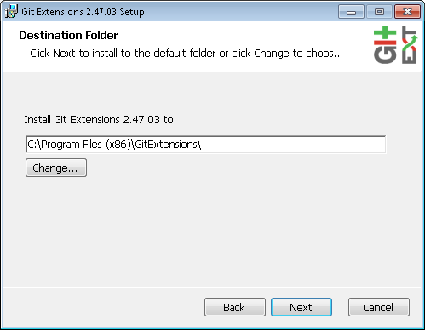

Leave defaults:

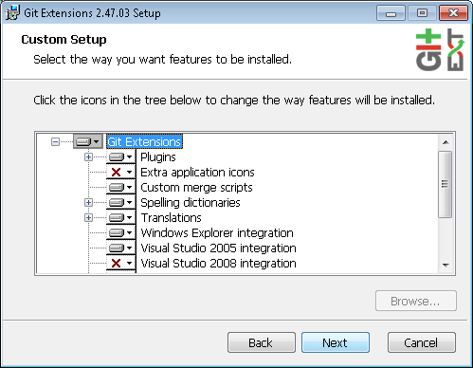

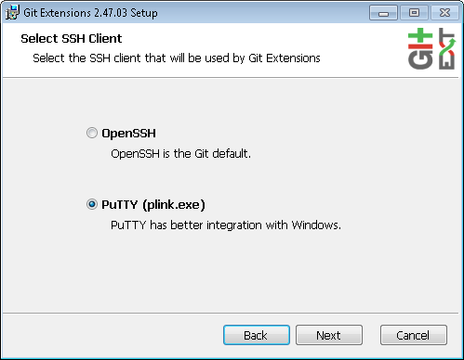

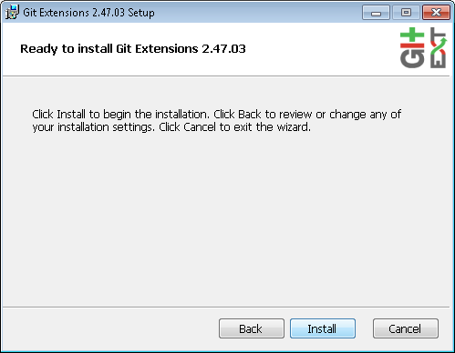

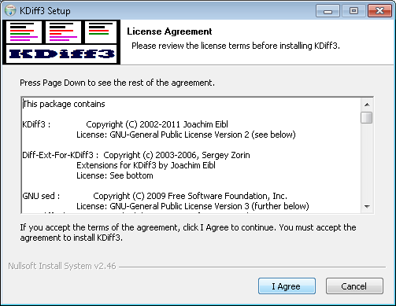

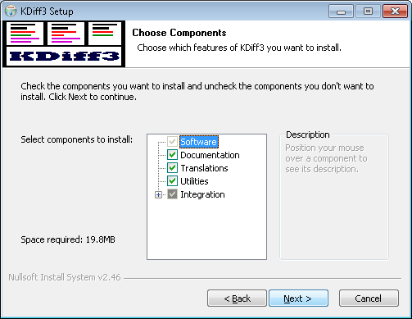

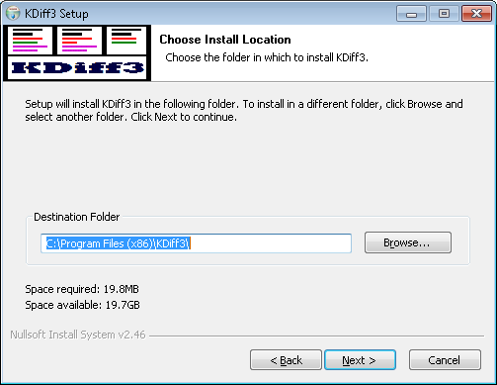

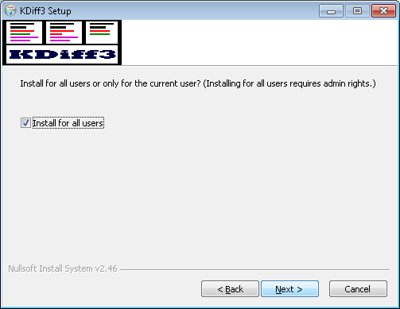

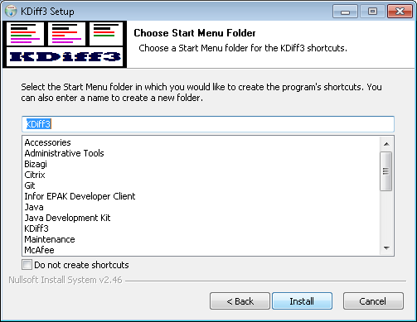

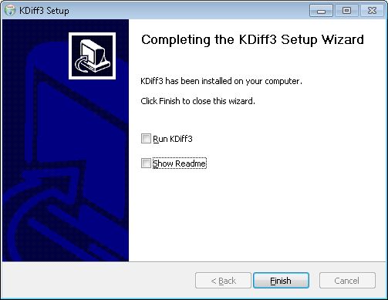

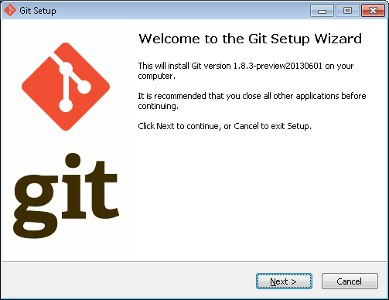

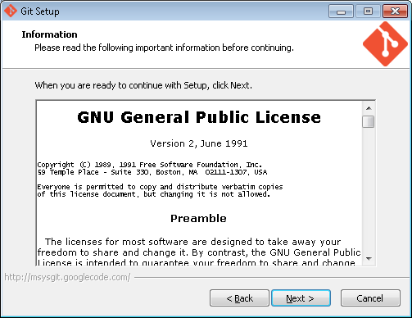

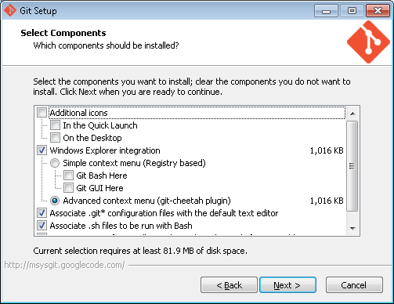

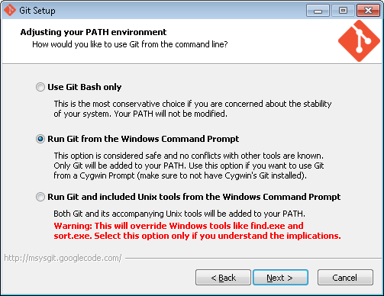

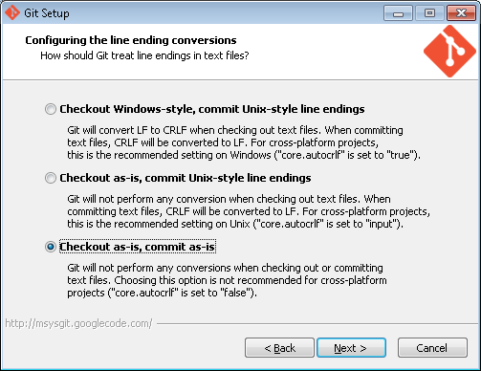

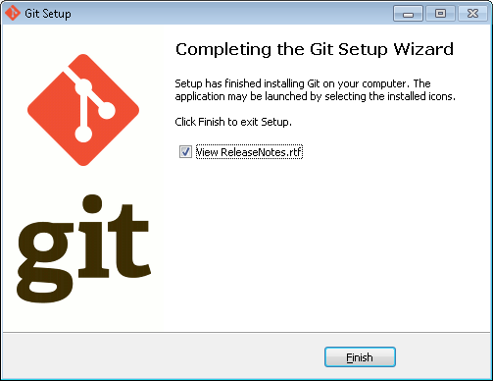

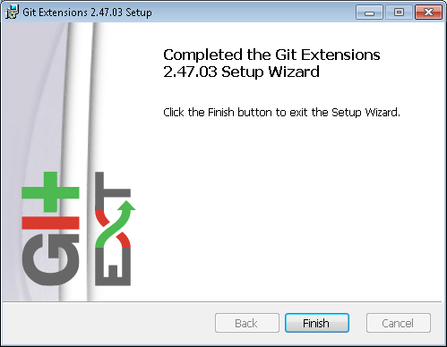

Install the BlackBelt tool from: “BB Installer\setup.exe”

As soon as you run the application and you will see this screen:

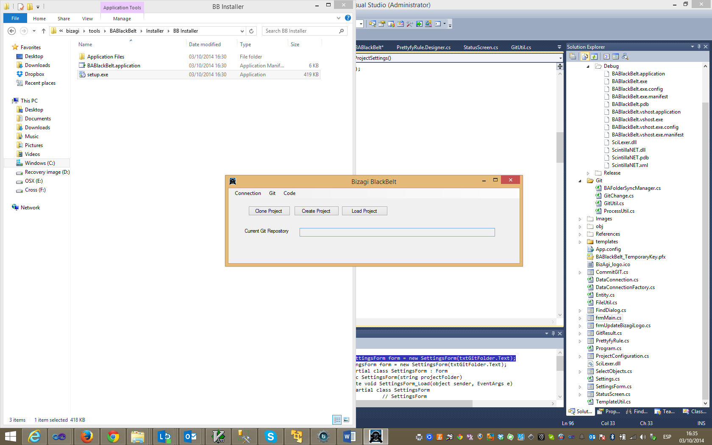

If it’s the first time you run the tool then you will need to create a project or to an existing one.

**Create a new project**

This step needs to be performed only once for each Bizagi Database you have in your environment, if you already did this go to the section “Connect to a project”.

1. Click in the button “Create Project” and you will get this:

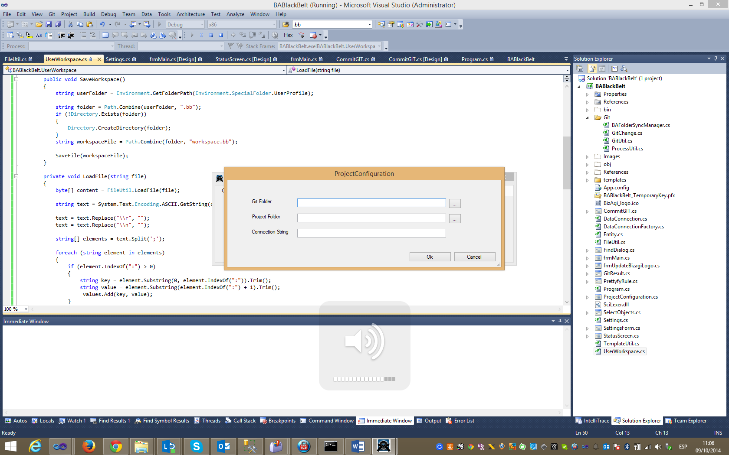

**Git Folder**: shared folder where Git is going to store all the information about the version.

**Project Folder**: Local folder where the changes are going to be stored and monitored.

**Connection String**: Bizagi Database connection string. (only SQL Server is supported at the moment and the password should be unencrypted)

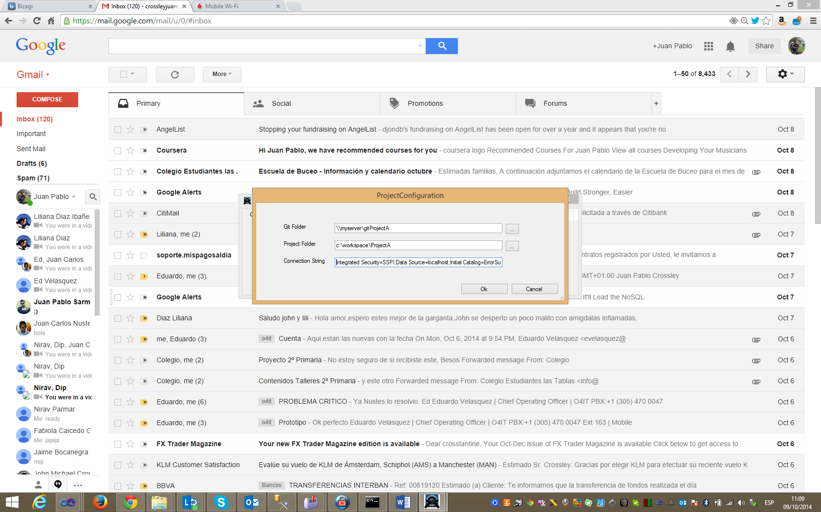

Click ok and you are ready to go.

**Connect to a project**

The first step to connect to an existing project is “cloning”, this step will download the contents from git and store them in a local folder. If you already cloned the project just click “load project” and select the local folder where you stored the clone.

*Cloning an existing project:*

Click in the button “clone”, it will pop up a screen to input the git folder at the server, the code repository is in \\slk30as0150v\workspace\git\PHOENIX, if you have a mapped drive it will be easier to find.

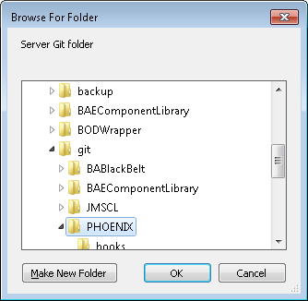

The next screen will ask for your local repository, here’s the folder where we are going to put the code from the cloned repository, let’s use c:\workspace\PHOENIX.

It will show you a confirmation screen like this:

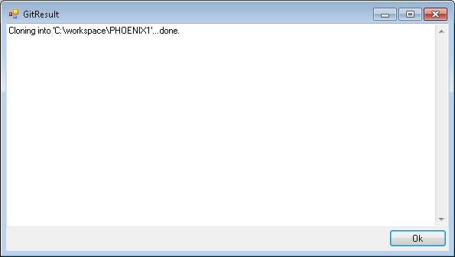

Now you are ready to start using git in our project,

Done!

**Commit your rules and entities**

When you finish your changes you will use the “Git – Commit Rules” Option to browse the files changed, select the files to commit and then add a comment to the commit.

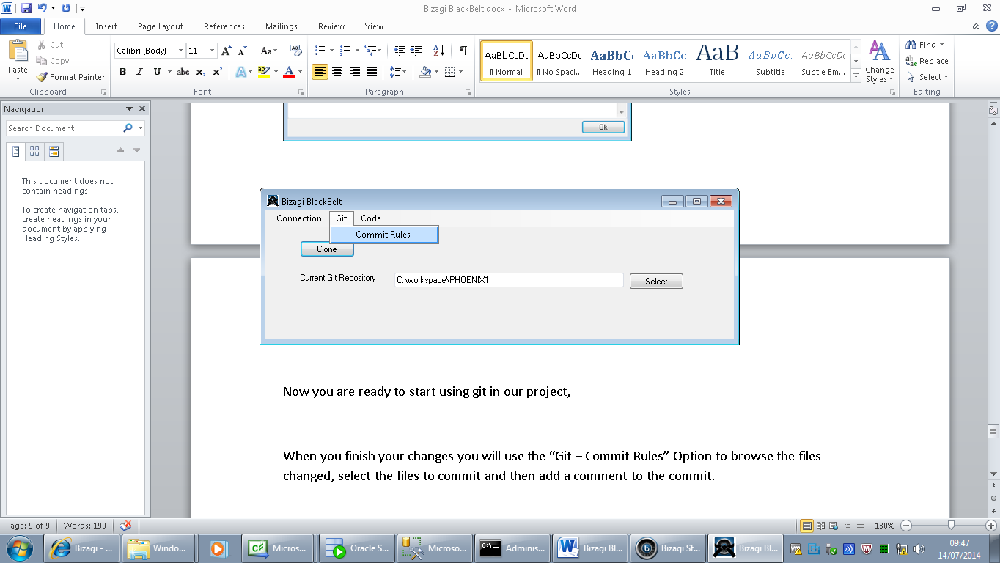

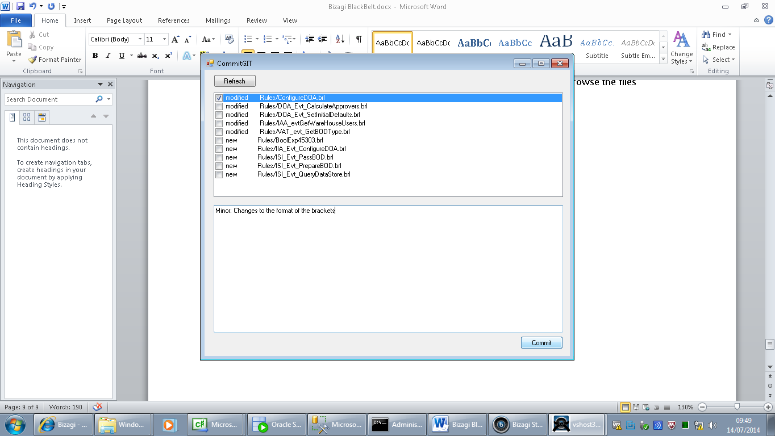

When you commit your changes, the BB will perform the following tasks:

Pull the latest changes from the server, commit your changes and push them to the server, then it will refresh the screen to show the new status.

Diff tool, in the “modified” files you can use the diff tool to check the changes, just select the file, right click on it and select “Show Diff Tool” from the menu or press F3, as shown below:

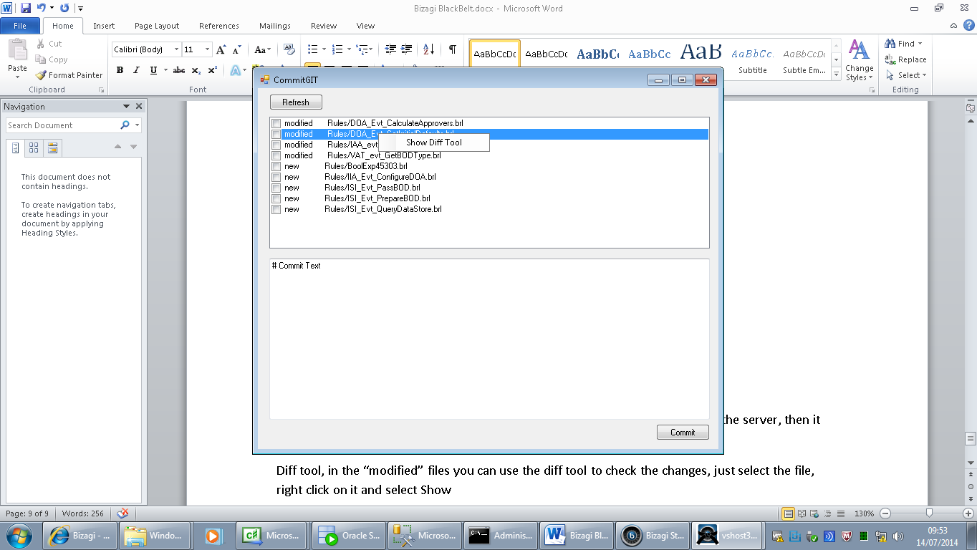

**Note**: this diff tool works with Modified files only.

Please use the following standard in your git comments:

<change type>: <summary>

The changes types are:

* minor: usually format changes, line spaces, comments, etc.
* major: any change to the logic of the rule. These are the ones that will be used in the “Release Notes”